Nama : Hafizh Umar Syafiqh

NIM :18090138

Kelas : 5D

**PRAKTIKUM 3**

1. Source Code

Matakuliah.php-> application/controller

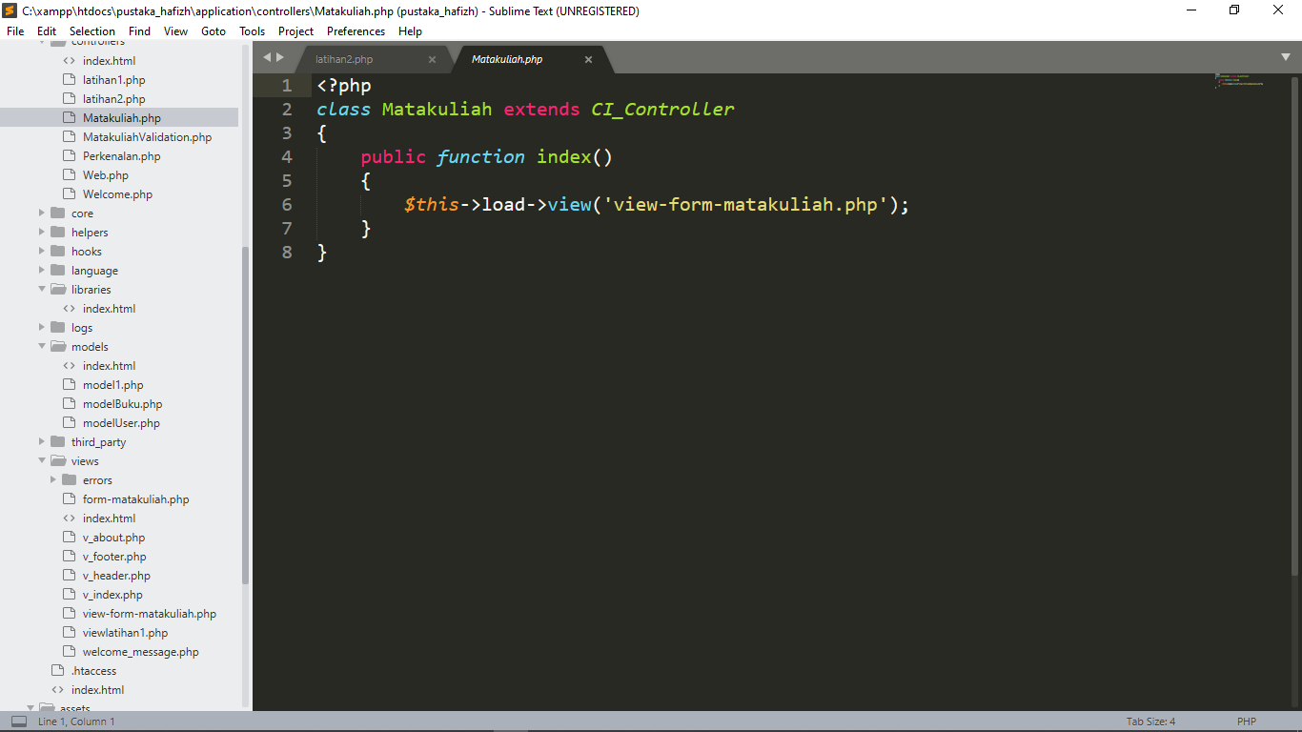

View-form-matakuliah.php->application/view

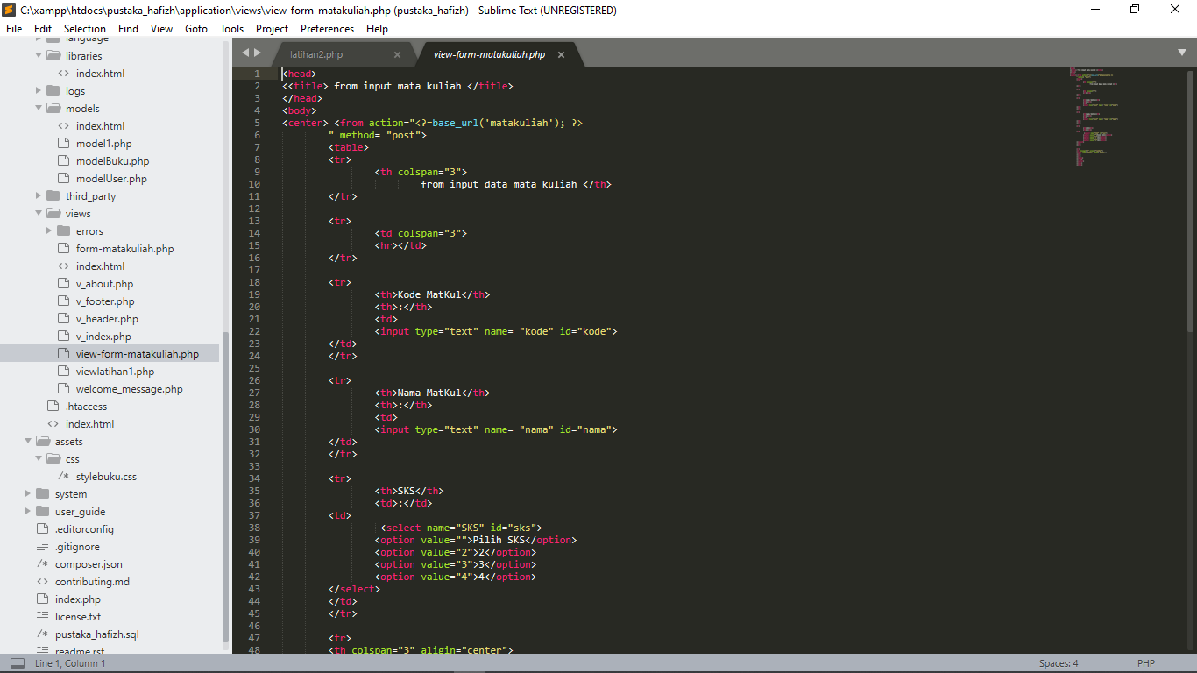

1. URL

<http://localhost/pustaka_hafizh/index.php/Matakuliah>

1. Capture Hasil

